LAB 9

Exercise 1 — Basic: Enum Level
File: LevelDemo.java
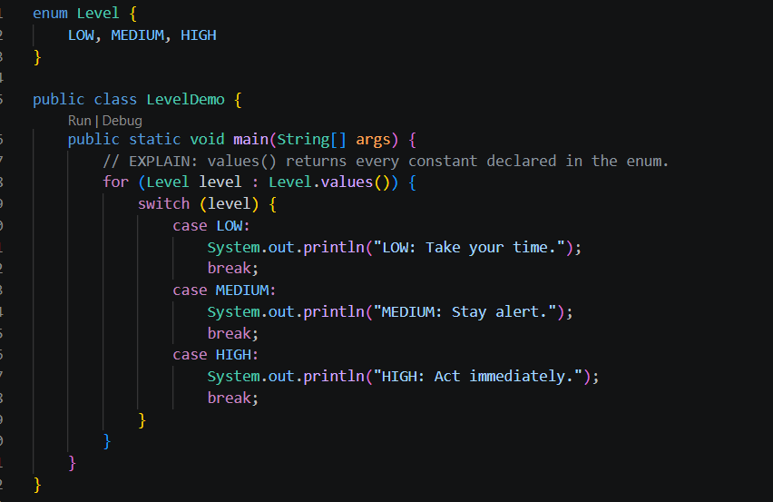

Output
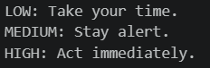

Exercise 2 — Basic: Create a Student record
File 1: Student.java
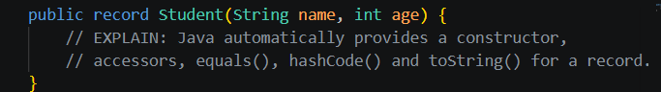

File 2: StudentRecordDemo.java
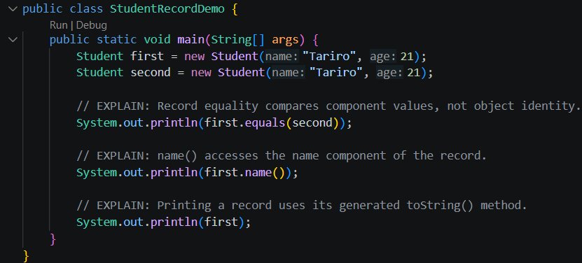

Output
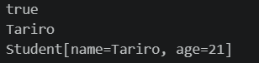

Exercise 3 — Intermediate: Book equality by ISBN
File: BookDemo.java
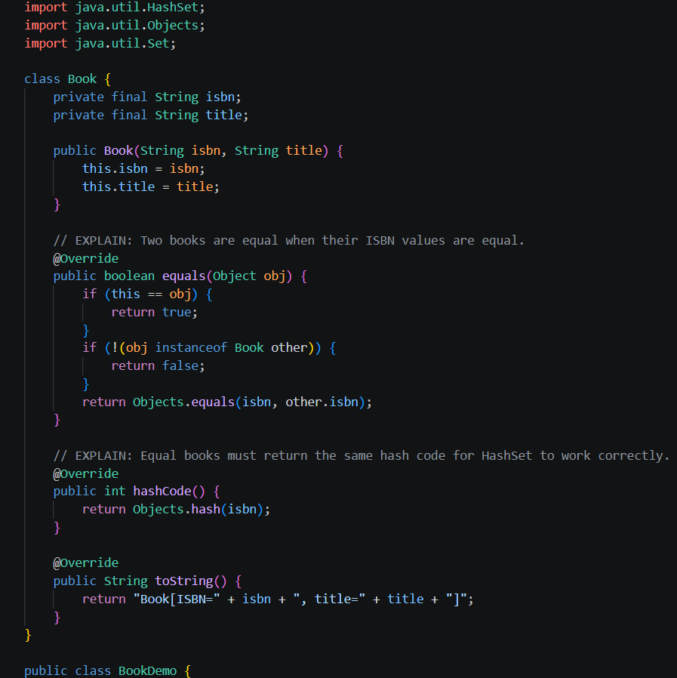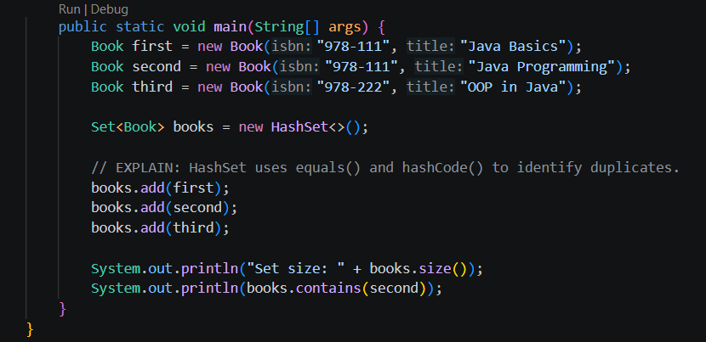
Output
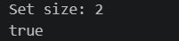

Exercise 4 — Intermediate: Linked list with nested Node and inner Iterator
File: LinkedListDemo.j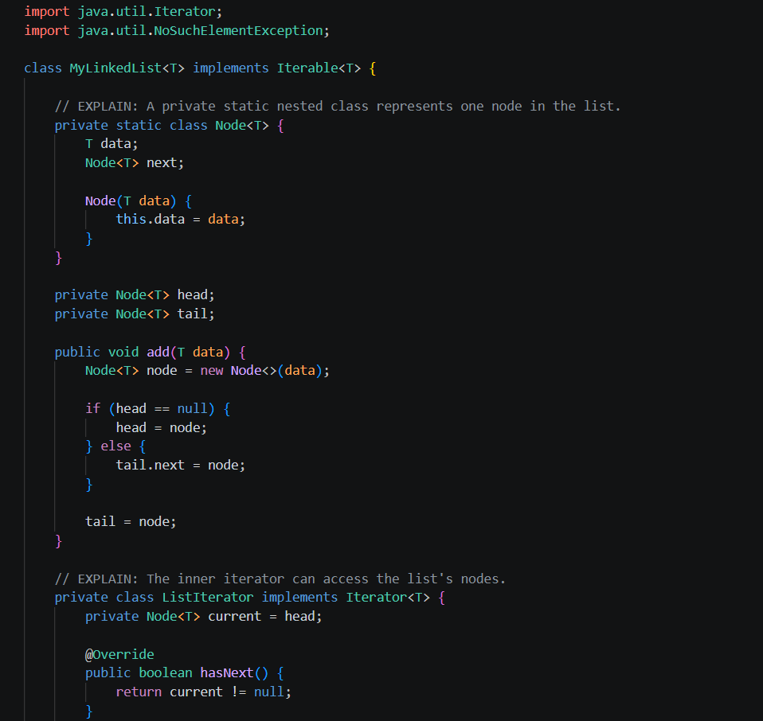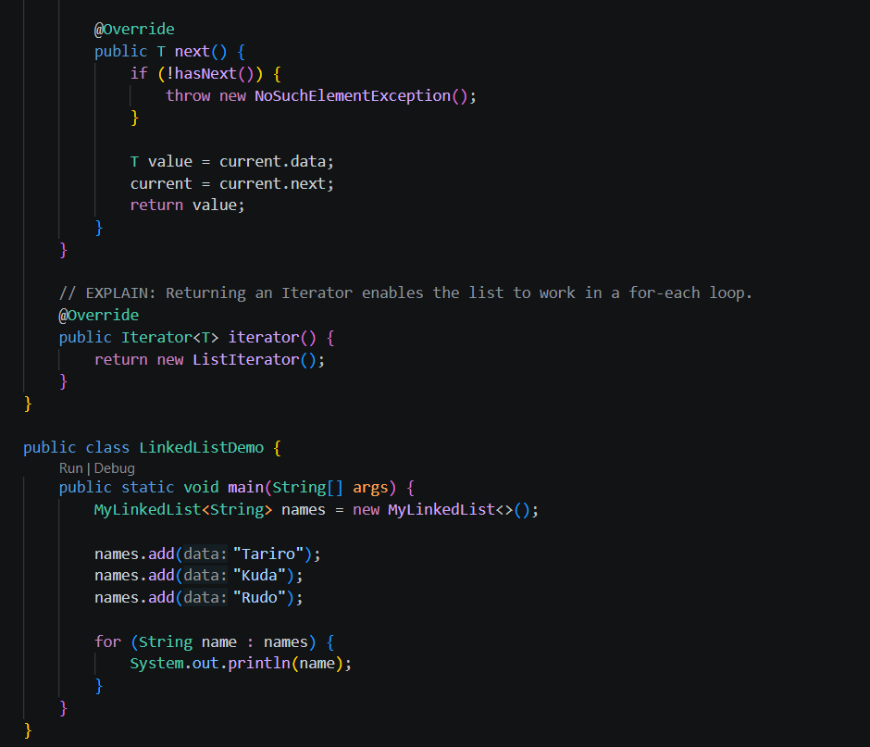
Output


Exercise 5 — Enum Coin and minimum coins
File: CoinDemo.java
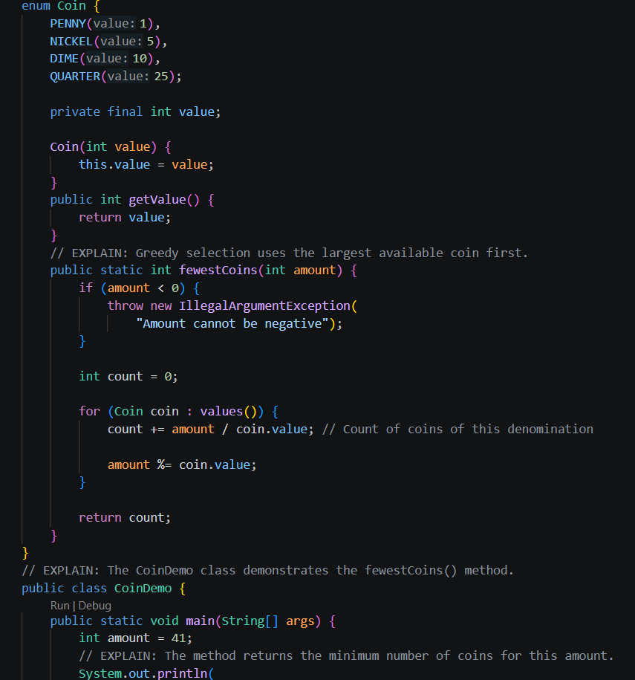
Output

